Unity Team
Matteo Dell’Oro, Alfio Giuliano Faro, Gabriel Logronio

PROTOTYPE LEVEL DIAGRAM

Purpose | Document containing the level diagram, description, flowcharts and event diagrams
Creation date | 11-12-2017
Current owner | Gabriel Logronio
Last modification | 11-12-2017

Revision History
Who | When | What
Logronio | 11-12-2017 | Created this document

Level Diagram

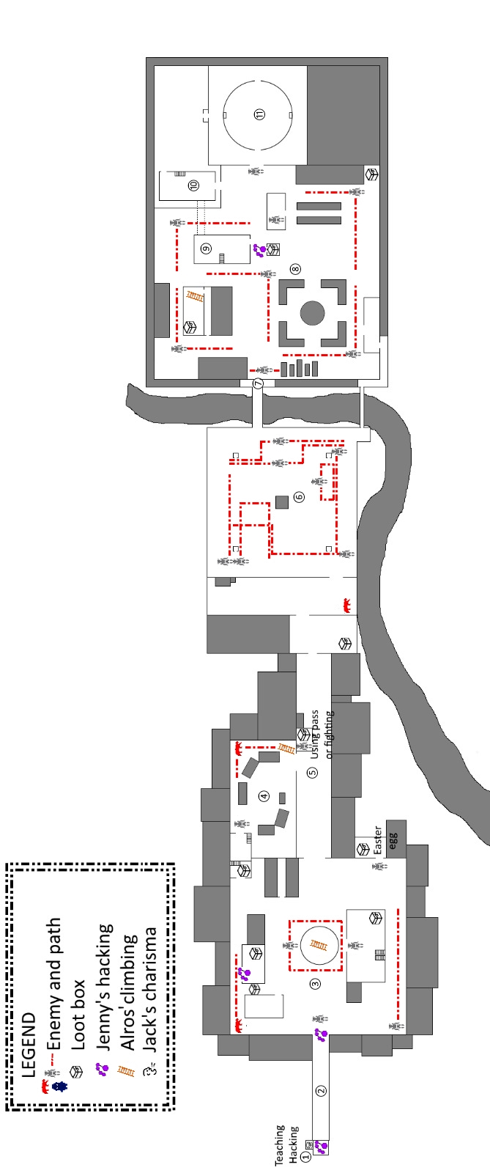
GROUND FLOOR

FIRST FLOOR

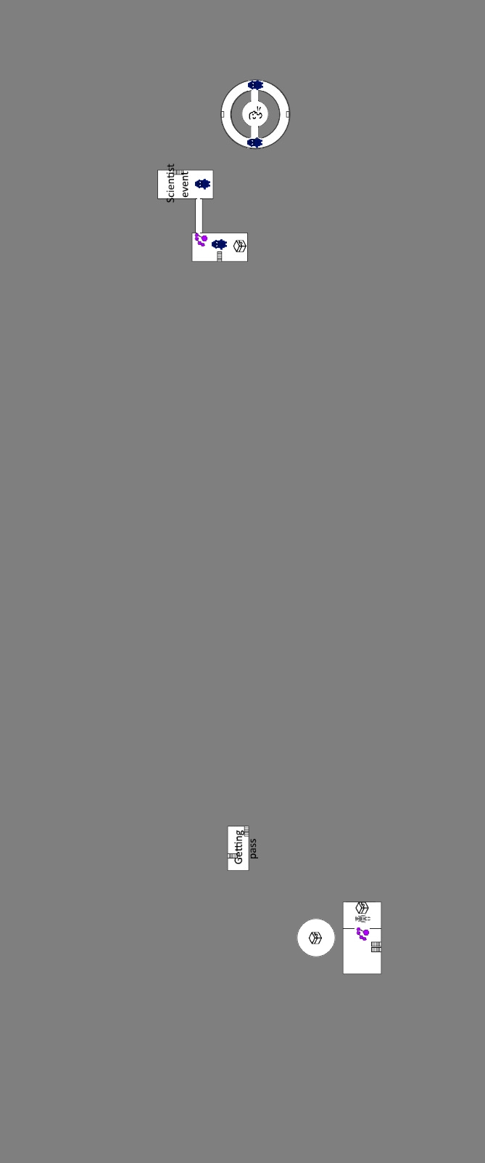

SECOND FLOOR


Level Description

1) Gas Station

Once the level starts, the player will be taught how to use Jenny's skill (Hack). The player will have to learn it in order to open the gas station warehouse, where he can find a reward that could help his progression through the level.

2) Road leading to the town

Not much to do here; the player will be forced have to go forward towards the town. The city door will need to be unlocked with Hack, testing if the player has actually really learned the skill.

3) Town Square

Once in the city, the player will have to fight the first enemy right beside the door, as this will trigger a cutscene explaining the purpose of the town exploration and the first sight of the factory at the horizon. After that, the player is free to roam the various buildings/areas connected. As it can be seen from the map, the player can engage different enemies, use Alros' Climb in the middle fountain (to get a reward), or find a reward between houses 1 and 2. The Boulevard is directly accessible while the Market can only be accessed through entering house 4.

House 1 - Exploration only.

House 2 - The player needs to use Hack in order to enter the house, once inside a reward can be easily found.

House 3 - In order to enter this house, an enemy has to be killed. Once inside, a substantial reward will be found together with an easter egg (not yet decided).

House 4 - On the first floor, on the town square side, a reward can be found. On the second floor the pass, which can be used in order to skip the guard post fight, can be found with a little bit of exploration. The right side exit of the building leads to the Market.

City Hall - The City Hall is the main building of the Town Square. Once inside, the player will have to fight an enemy near the door. Other than that, on the first floor, a reward can be find in a corner. On the second floor instead, a door is locked but Hack can be used on it; once inside the inner room, an enemy will be found guarding a reward. This is one of the few times in the game where using a skill might result in a negative outcome.

4) Market

The market is a large area filled with stands, obviously abandoned and in ruins, where the player can roam around and explore. Two enemies can be found, one just outside House 4 and one behind the stands in the corner. On the bottom-right corner, Alros' Climb can be used to get on top of the guard post of the Boulevard, where a skylight will let the player see the composition of the enemies inside it.

5) Boulevard

The Boulevard is a long straight street, without much possibility to explore around. At about half way through, a guard post has a big group of enemy inside. They can be challenged for a reward, or skipped (only if the player found the pass in House 4). On the left pathways leading to the Town Square and the Market can be found, while on the right the entrance of the Building with the light can be found.

Building with the light - Place with a key importance for the story: a cutscene will play once inside it, showing the rear door and the light coming from the factory. In the bottom-left corner, a small reward can be picked up.

6) Mine field

Clara separates from the group, and starts the puzzle: the player must guide her find a way through a mine field to disabilitate the 4 generators that feed the area, following the cybermen's path and hiding behind obstacles.

7) Factory Entrance

Main Door - Main entrance to the Factory, easily visibile but strongly defended. It can be accessed only after the mine field puzzle has been solved.

Sewers - Side entrance to the Factory, barely visible but without any direct defense. As with the main door, it can only be accessed after the the mine field puzzle has been solved.

8) Yard

Biggest part of the Factory, where the player is free to roam around. Many guards patrol most of the paths, and a reward can be found in the bottom-right corner. Warehouse 1, 2 and 3, Building 1 and Building 2 can be accessed through various means. The tower can't be directly accessed: many guards control the direct entrance, and even if the player manages to take them out, the gate will be locked.

Warehouse 1 - While the door is locked, Climb can be used in order to have Alros reach an opened window from where he can get inside the building and open the door from inside. A reward can be found once those steps have been fulfilled.

Warehouse 2 - A tiny room, with the door locked but accessible using Jenny's Hack. A reward can be found inside

Warehouse 3 - A small and empty building with an enemy inside.

9) Building 1

First of the two buildings where scientists can be found; while the ground floor is empty, the upper floor contains an enemy guarding a reward, and the possiblity of using Hack in order to unlock a narrow bridge that leads directly to Building 2 upper floor.

10) Building 2

Key building of the Factory complex, where the player has to complete the Scientist event in order to have the pass that unlocks the Tower's elevator. An enemy will be challenged in the Scientist event, but no rewards are located inside the building.

11) Tower

Link path - A small patch of ground linking the rear exit of Building 2 to the top entrance of the Tower yard.

Tower yard - The outside of the tower, with a front entrance and the rear entrance. Entering the tower through the front entrance might risk triggering a battle with the main gate guards (it is avoidable, but it requires perfect movement).

Tower - Once inside the tower, two elevators can be found at the North and South spots, with the same functioning but that can be activated only once the player has completed the Scientist event in Building 2. Once inside the elevator, the player can choose between going to Floor 1 or Floor 2. On floor 1 (optional), two different enemies are guarding the entrances to the tower core room, where Jack's Charisma can be used in order to obtain a big reward from the scientists inside. On floor 2 (mandatory in order to finish the level), a reward can be found on the East side consisting in items useful to face Strax, the final boss. On the West side on the other hand is where Strax's room is located: entering it will trigger the boss fight.

Flowcharts

Coming soon

Event Diagrams

Coming soon

Concept Art

Coming soon

